**Tech-Hub Pay**

**(Hight level Design Document)**

Contents

1. Scope 3

2. Functional Requirement 3

2.1. Tech-Hub Pay 3

2.2. Central Bank of Egypt (CBE) 3

2.3. Bank (Issuer, Acquire, …) 4

2.4. Payment Service Provider (PSP) 4

2.5. Card Bank (ex: Miza) 4

3. Non-Functional Requirement 4

3.1. Tech-Hub Pay 4

3.2. Central Bank of Egypt (CBE) 4

3.3. Bank (Issuer, Acquire, …) 4

3.4. Payment Service Provider (PSP) 4

3.5. Card Bank (ex: Miza) 4

4. System Design 5

4.1. High-Level Architecture 5

4.2. Simulated Logical Diagram 6

5. API for the Interfaces 7

# Scope

* It facilitates transfer money from different banks instantly.
* Allows direct access to all your bank accounts.
* Provide transactions between deferent types of accounts (Bank account – Wallet – Cards – TechHub pay account – Merchant).

# Functional Requirement

## Tech-Hub Pay

* + - Send and receive payments instantly.
      * Send Transaction
        + To Mobile Number

Tech-Hub Pay

Wallet

* + - * + To Wallet Number
        + To Bank Account (IBAN)
        + To Bank Account using IPA
        + To Meeza Card
      * Receive
        + Receive Money: share your IPA or Mobile number
        + Initiate Collect Request: Request money from others using mobile number or IPA
        + Send payment request for more than one person with one receipt. [Multiple collect – Split amount]
    - Manage all user accounts balance in one place.
    - Response to and Management of Events.
    - Registration
      * User Name
      * Mobile Number
      * Email
      * Password

User IPA 🡪 Bank Account (default)

Bank Account

Bank Account

## Central Bank of Egypt (CBE)

Overview: Act as payment gateway, payment processor and proxy.

* + - Transactions logs.
    - Payment Gateway

## Bank (Issuer, Acquire, …)

Issuer:

* + - * + Responsible for documenting
        + Validating Data
        + Manage Failure
        + Approve transactions
        + Provide Minimum and Maximum limits
        + Deal with different type of Banks
        + Notify the users

Acquire:

* + - * + Accept Transactions approved by the CBE and IPN
        + Adopt electronic acquiring method by CBE and IPN

## Payment Service Provider (PSP)

## Card Bank (ex: Miza)

# Non-Functional Requirement

## Tech-Hub Pay

* + - Set maximum and minimum limit value per transaction.
    - The (daily/monthly) maximum and minimum value of transactions.
    - Available 24/7.
    - Information Confidentiality and Integrity.

## Central Bank of Egypt (CBE)

* + - Analysis …

## Bank (Issuer, Acquire, …)

Acquire:

* + - * + Possibility of the acquiring bank’s contracting with merchants/companies directly or through the assistance of Payment Facilitator after obtaining the necessary approvals from the Central Bank of Egypt.

## Payment Service Provider (PSP)

## Card Bank (ex: Miza)

# System Design

## High-Level Architecture

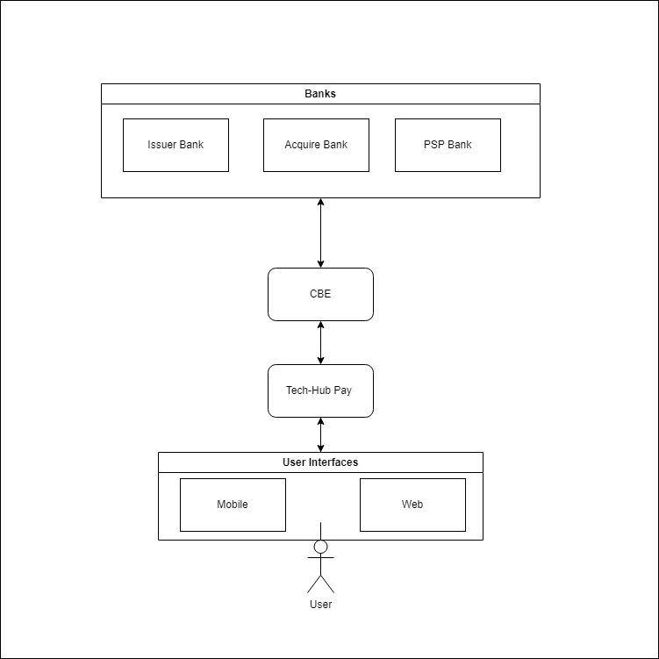This diagram demonstrates how the system work generally:

## Simulated Logical Diagram

It will simulate the components of the transaction flow:

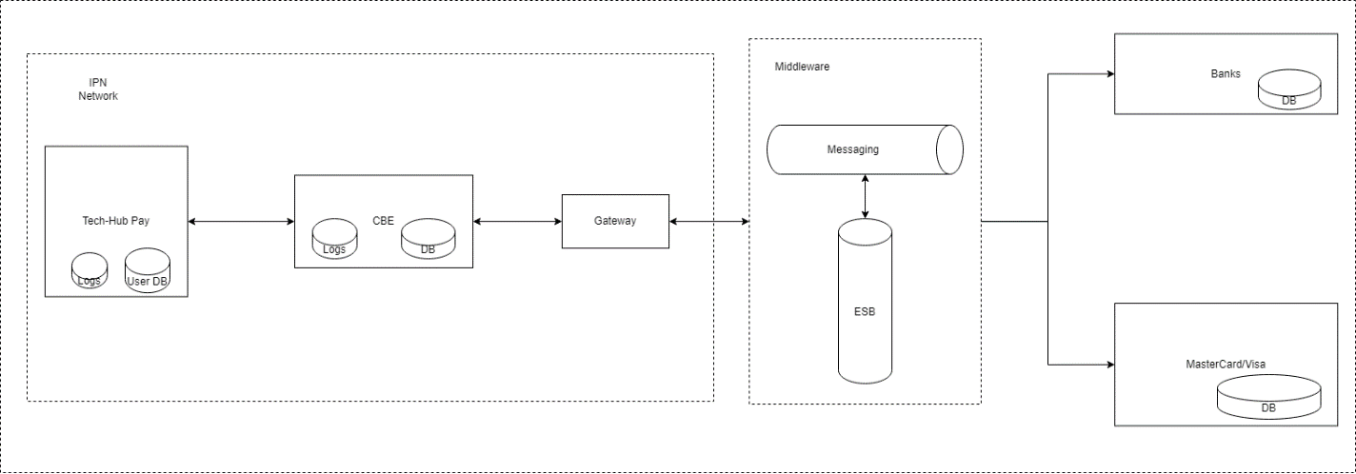

# API for the Interfaces

These are the basic APIs should be provided to the user interface:

|  |  |  |  |  |
| --- | --- | --- | --- | --- |
| No. | End Point | Input | Output | Notes |
| User Authentication | | | | |
| 1 | Register | * User name * User National Id * Account number * Account mobile number * Email * Password | Registration accepted or Not |  |
| 2 | Login | * email * password | * token |  |
| User Accounts list | | | | |
| 3 | Accounts | * user id * token | List of account data  Ex: Card number - balance – bank name |  |
| Balance Inquiry | | | | |
| 4 | balance | * user id * card number * token | * balance |  |
| Account History | | | | |
| 5 | history | * user id * token | * all user transaction |  |
| Transfer | | | | |
| 6 | Send Money | * user id * token * from account * to account | Success or fail with a reason. |  |
| 7 | Receive Money | * user id * token * sender account * to account | Success or fail with a reason. |  |

# Questions:

1. Is the IPA unique for every Bank Account or for a single user?
2. اي الحاجه اللي هتروح للبنك المركزي من instapay؟
3. هوا في اخر خطوه ال issuer bank بيكلم ال Acquire bank علطول ولا بيعدي على البنك المركزي ؟